Chapter 5/6 Problems

Zachary Sisco

**CHAPTER 5**

1. 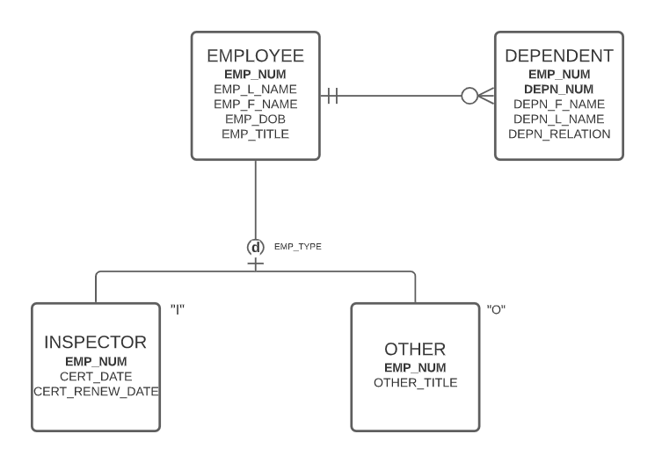Diagram:
2. Diagram:

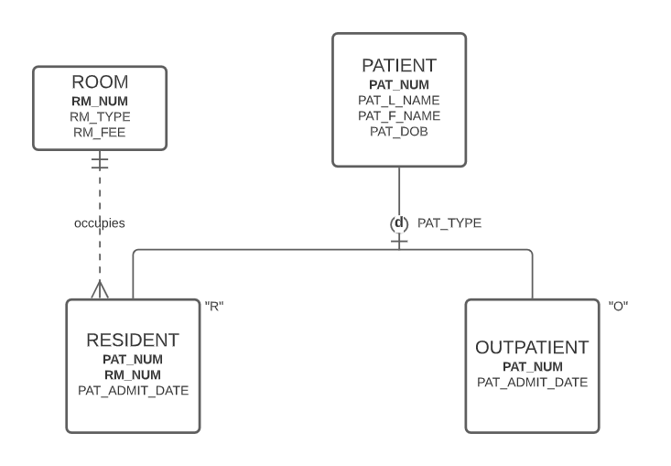

**CHAPTER 6 CONTINUES BELOW**

**CHAPTER 6**

1. Dependency diagram:

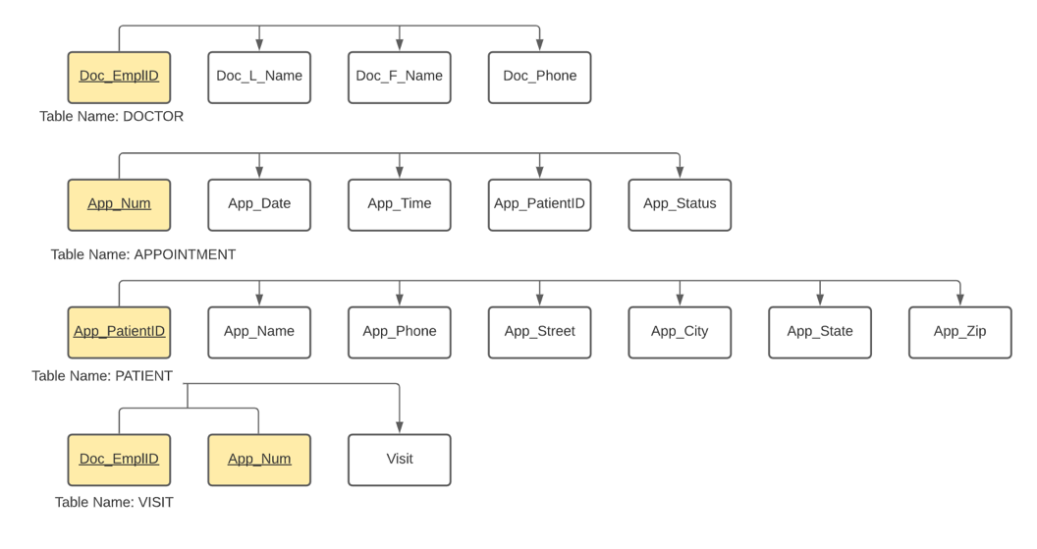

1. Dependency diagram:

